Manual

QD-18-KF Automatic Drip Coffee Bag Packing Machine with Outer envelope (Upgrade)

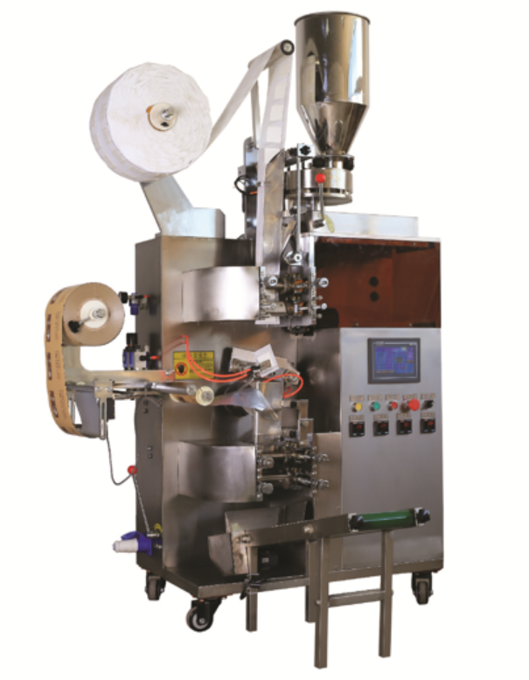

I．Preface 3
II. Description and Specifications 4
A. Application: 4
B. Features: 4
C. Parameter 4
D. Packing material and working environment: 5
III.Operation 6
Warning: 6
THE SEQUENCE OF STOP 7
Machine transportation and installation 8
IV. Brief Introduction to Control Panel 10
V. Operation and Adjustment 10
※.Touch screen 11
※Use methods of the temperature control gauge 17
※Wrapping of the inside bag filter paper 18
※Adjust the shaper of the filter bag(inner bag) 20
※Adjustment for vertical sealing roller of inner bag............................21
※ Adjustment for horizontal sealing roller of outer bag.......................23
※Adjustment for vertical sealing roller of outer bag............................25
※Adjustment of open/close device..........................................................27
※Adjusting the open peg and close peg..................................................28
※ Adjustment of the pneumatic bag catching manipulator.................29
※ Adjustment of traverse seal eccentric mechanism............................30
VI.Electric Wiring Diagram 33
VII. Trouble-shooting 34

I．Preface
Many thanks for your purchase of our automatic drip coffee bag packing machine model QD-18-KF. This operation manual serves to guide you how to operate the machine properly and guide you how to conduct some basic trouble shooting by yourselves. Kindly read this operation manual carefully prior to the operation.
Cautions:
- Please do not discretionarily make any commissioning or amendments to this machine as it has been testified eligible by strictly commissioning and verifying all its components and mechanisms before ex-works. Should there be any more queries after the reading of the manual, please contact the company’s After-sales Department.
- We hope for your understanding and forgiveness as the manual may be somewhat different from the machine itself should there be any partial modifications to the machine.
- The manual only gives a simple account of the machine’s maintenance. Please contact our After-sales Department should the machine have any faults that you can’t solve.

II. Description and Specifications

A. Application:
The machine is suitable for the dual bag packing of small granular products, such as drip coffee, medicinal tea and herb teas, etc.

B. Features:
  - Controlled by a step motor, the outer seal has a fixed length and a correct position.
  - PID is used to adjust the temperature controller for more accurate temperature control
  - PLC is used to control the motion of the whole machine, with a human-machine interface display and easy operation
  - All touchable material parts are made of SUS304 stainless steel to ensure sanitary and reliable products
  - Some of the working cylinders use OEM parts to ensure steady and accurate performance
  - The optional device has functions including cutting, date printing and easy tearing.

C．Parameter
Bag form method: 3 side sealing;
Measure: 6-8 grm/bag;
Size of inner bag (max): 78(length)x90(width) mm;
Size of outer bag (max): 120(length)x100(width) mm;
Ability: 30-60bag/min;
Power: 220V, 50Hz, 3.7KW
Heater: Heat pipe for vertical sealing of inner bag: 350w 2 pieces;
Heat pipe for horizontal sealing of inner bag: 350w 2 pieces;
Heat pipe for vertical sealing of outer bag: 350w 2 pieces;
Heat pipe for horizontal sealing of outer bag: 350w 2 pieces.
Dimension: 1200(L)x900(W)x1900(H)mm
Weight:400kg

D. packing material and working environment:
1. The drip coffee filter paper:
Paper standard: heat sealable filter paper;
- Packing film of the outer bag:
Compound wrappers of film/polythene, cellophane/polythene, ethylene/polythene and aluminum/polythene
- Working environment: no dust, 10°C - 40°C, the relative humidity should be less than 75%.

III.Operation

Warning:
    - Connection ground credible for avoid acne electric shock;
    - Keep the environment dryness;
    - Cut the power off when setting the packing material;
    - If the motor run reversal will made the part broken. don’t turn motor of the machine reversal;
    - Running
    - Ready to running:
    - connected the grounding reliable;
    - turn the power on;
    - setting all of sealing temperature;
    - setting the filter paper roll on; setting the outer bag film roll on;
    - running step by step
- turn all handles (products filling handle, inner bag forming handle) off;
- Feed the filter paper into the sealing roller and press the “run” key and turn the speed knob on the speed controller plate running the machine to make the empty inner bag. Make sure the inner bag (drip coffee bag) forming well. Then press the “stop” key stop the machine;
- Feed the outer bag film into the outer bag sealing roller and running the machine to make outer bags. Make sure the outer bag forming well;
- Close the products filling handle. Make sure the time of fill to a turn.
- If both of the inner bag and outer bag look well, start production.

THE SEQUENCE OF STOP
  - turn the filling handle off;
  - turn the inner bag forming handle off;
  - press the “stop” key on the speed controller plate to stop the main motor;
  - cutting the power off;
  - Clear the machine.

Note: When the machine stops, make sure all of sealing rollers does not touch the filter paper or the outer bag film to avoid burning the film.
  - Note:
- When the machine is running, pay attention to the sound from the machine. If sound deviant, stop the machine at once and take the inspect be carefully for flaws;
- Brush the faces of all of sealing rollers with the copper brush when machine stops running. To prevent the dregs of the burned film adhere on it;
- It is unwarrantable to put the hand or tools close the parts running;
- Checking regularly to see if each part connects well or not.
- Changed the oil of the gear box every 3 months.
- Lubricated all running part every day.

Machine transportation and installation
a. Transporting
You can use the wheels which are installed under the four angles of packing machine to remove it in the workshop or factory. The ground must be flat, or else it would easily damage the wheels.
For long-distance transport of the machine, the out box used for packing the machine must be firm. We fixed the machine to the soleplate of the box firmly. The out of the box print the warning that inversion or impact is not allowed.

b. Installation

- Make sure connect to the grounding wire in order to avoid injuring of electricity .
- The packing machine must keep of the moist area and high voltage power supply.
- Please turn off all of the power supplies before set the packing materials in order to avoid accidents.
- You had better adjust the velocity under the condition that the packing machine is running by the electric motor.
- Please put the packing machine on the shady and cool area where far from the sunlight.
- Please do not operate the machine reversely, otherwise, the machine can be damaged. Adjust the machine by hand, please don’t rotate the hand wheel reversely.
- Please clean the machine frequently, and add the lubricating oil on a regular basis.
- Change the oil in the decelerating machine every 3 months.

IV. Brief Introduction to Control Panel

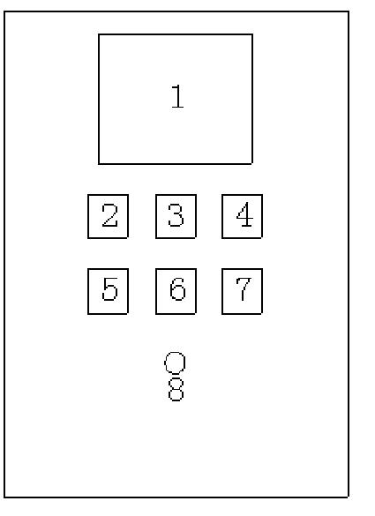
1. Human-machine interface (touch screen)：
See the touch screen interface instructions for details about the operating platform and settable parameters
2-6. Inner and outer bags temperature control meter
Adjust the temperature for sealing (based on the melting point of packing material)
7. Ammeter:
Display electric current values when the label, vertical seal and horizontal seal are heating up
8. Knob
Press this button to start the equipment

V. Operation and Adjustment

※.Touch screen

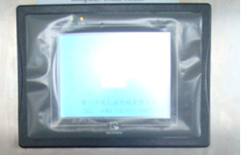
A-1
1． and in the interface A - 1, but according to the language habits and choose the "Chinese 'interface or' spending 'interface. After selecting Enter interface A - 2
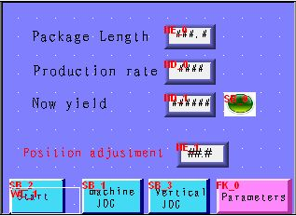
A-2
2、In the interface A - 2, the light touch keys function and use the method is as follows:
Package Length：Is shown in the outer pocket now installed by cutting and length. According to the bag length
Production rate：Show is the machine runtime production efficiency. Shows is now set set
up different Numbers, setting method: click '# # #. #' position, input needed Numbers, press ENT confirm can.
Now yield：Show is production quantity. Click remove can make display output zero.Position adjustment：Click packaging with standard select key to select the bag is tracking brunet label, light color standard or not tracking.
：In stop condition, click hosts started running after.
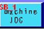 、：Click once, relevant equipment running again.
 ：Click enter interface A – 3
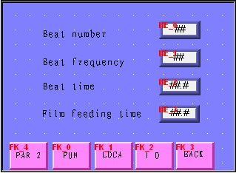
A-3
3、In the interface A - 3, the light touch keys function and use the method is as follows:
：Refers to knock action frequency, change '# #' figures may change the first and second knock it down time intervals, This number is in commonly between 0.2-0.4. Knock times: refers to the number of action; knock institutions When the packing materials poor liquidity, click "#" input digital, press ENT confirmation.
：Refers to knock action frequency, change "# # #" figure to change with the second under a knock the first time intervals.
：Refers to the film feeding time length, click "# # 'input digital, press ENT confirmation. Packing length in Settings for compensation: : do not follow, to compensate for the bag of a cutting length with setting the length of the difference. Click "#. # 'position into the Numbers, press ENT for confirmation.
：Refers to the small cylinder cylinder cores torre line out of time, torre live thread to wait for a single thread front by manipulator to send away, then returned to cylinder cores torre live drop down, lest cotton thread before and after two thread winding. Click "#. # 'position into the Numbers, press ENT for confirmation.
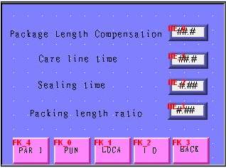
A-4
4、In the interface A - 4, the light touch keys function and use the method is as follows:
：Refers to the length of the outer pocket cut with
setting the length ratio. Click "# # #" input digital, press ENT confirmation.
：Refers to the horizontal closure with longitudinal sealing action frequency, change "# # #" digital may change the sealing time.
: Refers to the small cylinder cylinder cores torre line out of time, torre live thread to wait for a single thread front by manipulator to send away, then returned to cylinder cores torre live drop down, lest cotton thread before and after two thread winding. Click "#. # 'position into the Numbers, press ENT for confirmation.
: Packing length ratio: refers to the length of the outer pocket cut with setting the length ratio. Click "# # #" input digital, press ENT for confirmation.
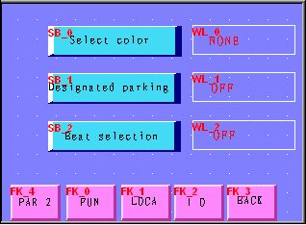
A-5
5、In the interface A - 5, the light touch keys function and use the method is as follows:
：Refers to standard switch, according to their own needs choice.
：Designated point stop button, according to their own needs choice.
：Refers to knock switch, according to their own needs choice.
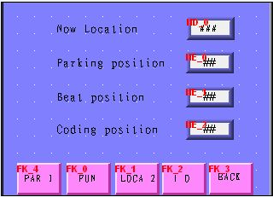
A-6
6、In the interface A - 6, the light touch keys function and use the method is as follows:
：Refers to the PLC internal procedures according to count promixity switches and speed switch input signal and determine the now stop condition get real-time position, this position number will not exceed 200.
：In the next stop condition, click on "#" can be installed after each downtime for a fixed position. (the position and the machine running speed how about) TingJiWei Settings above horizontal sealing and the seal are not under pressure to packaging film shall prevail.
：Click "#" display digital interface, input digital, press ENT for confirmation. This input number is the actual beating when the movement 'current position "the digital display, Change the number may change the knock action position.
 ：Refers to the fighting yards institutions have after PLC program control, internal fight code for time point; motor The figures are in fighting
yards maneuvering do 'current position "shows the real-time digital to set.
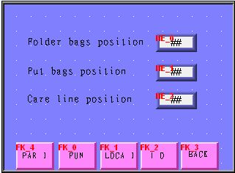
A-7
7、In the interface A - 7, the light touch keys function and use the method is as follows:
：Click "#" display digital interface, input clip bag manipulator operation to receive eccentric dish highs 'current position' the digital display, press ENT for confirmation. This input digital according to actual situation has + 1 ~ 10% of the floating range.
：Click "#" display digital interface, input put bag manipulator operation to receive eccentric dish low current position when ' 'the digital display, press ENT for confirmation. This input digital according to actual situation has + 1 ~ 10% of the floating range.
：Click "#" display digital interface, input digital, press ENT for confirmation.
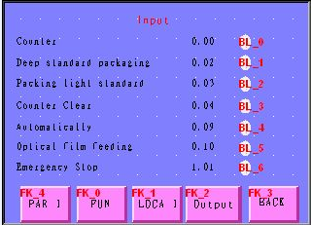
A-8
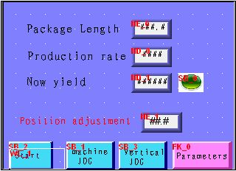
A-9
In the interface A - 8click monitoring enter A - 9 interface, the interface is shown PLC terminal input Signal wiring way, when all wiring end has signal input, the corresponding there will be flashing, otherwise should check The corresponding input.

※Use methods of the temperature control gauge
Heating output indicator light
Self-setting indicator light
Setting button
Shift button
Set value minus button
Set value plus button

4-2
1．Select different temperature settings and setting methods according to different packaging materials:
The number is displayed in the SV to flash by clicking the 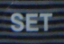, and then the required number flashes by clicking the "", and then add one or minus one by clicking the "" and "", so that the number displayed in the SV is the same as required number. Exit by clicking the ;
2．When the temperature difference displayed between the PV and SV is larger, enable the self-setting mode to re-set the heating coefficient; self-setting mode is implemented respectively according to the following order:
First set the temperature of 'SV', the temperature should be higher than 100C of the packaging film sealing solid temperature.
A、Hold down the for 5 seconds, so that PV display is changed from the number to the letter; the PV display is changed into the 'LOCK' by continuously clicking,
B．'0000 ' is displayed in the SV by clicking,;
C．'AT' is displayed in the PV by continuously clicking;
D．'0001 ' is displayed in the SV by clicking,,
Hold down for 5 seconds, so that PV display is changed from the letter to the number, exit the self-setting setting. At this time, 'AT' indicator light should flash, indicating that the heating coefficient starts to be calculated in the temperature control gauge; at this time, the power can not be off, or press any button on the gauge, otherwise it has to be reset. After the 'AT' indicator light automatically turns off, referring to the end of the self-setting. Afterwards, the temperature control gauge can automatically control the temperature based on the calculated heating coefficient.
Warning: For machine setting, the temperature shown in the temperature control gauge is the temperature at the beginning of the heating, that is, the ambient temperature. If the temperature is higher than the ambient temperature for above 20 degrees, the auto-setting parameters should be set after the temperature decreases, or else the control temperature will be inaccurate afterwards.

※Wrapping of the inside bag filter paper

Schematic Drawing of Film Feeding
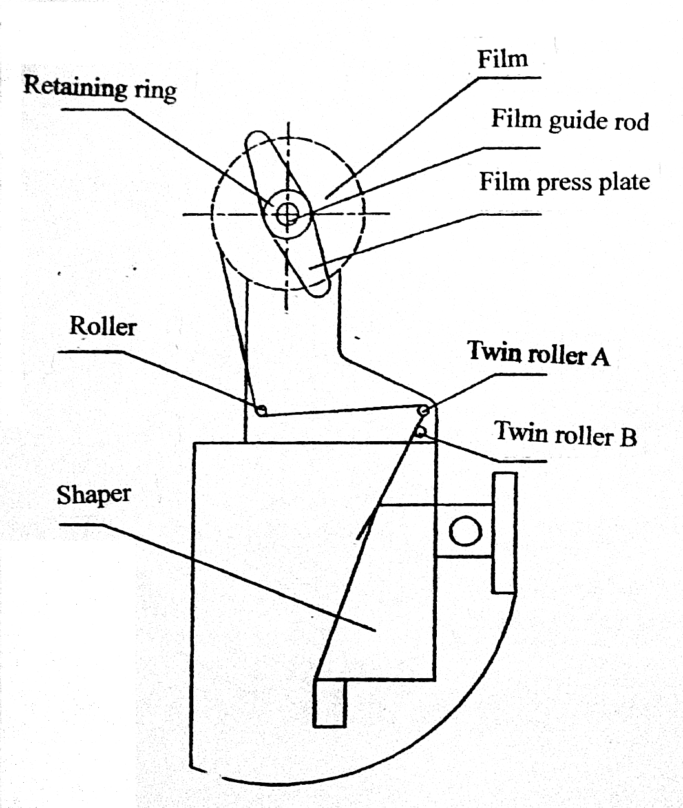

    - Release the retaining ring and take off the film press plate.
    - Feed the film into the film guide rod anticlockwise. Fit up the film press plate and retaining ring. align the film center to the sealing line. faster the retaining ring secure.
    - Feed the film against roller 1. Twin roller A and twin roller B. As shown in the figure. Insert the shaper. And the film feeding is completed. ( Prior to insertion of shaper, fold the film end section into two folds and cut it into a pointed shape.)

※Adjust the shaper of the filter bag(inner bag)
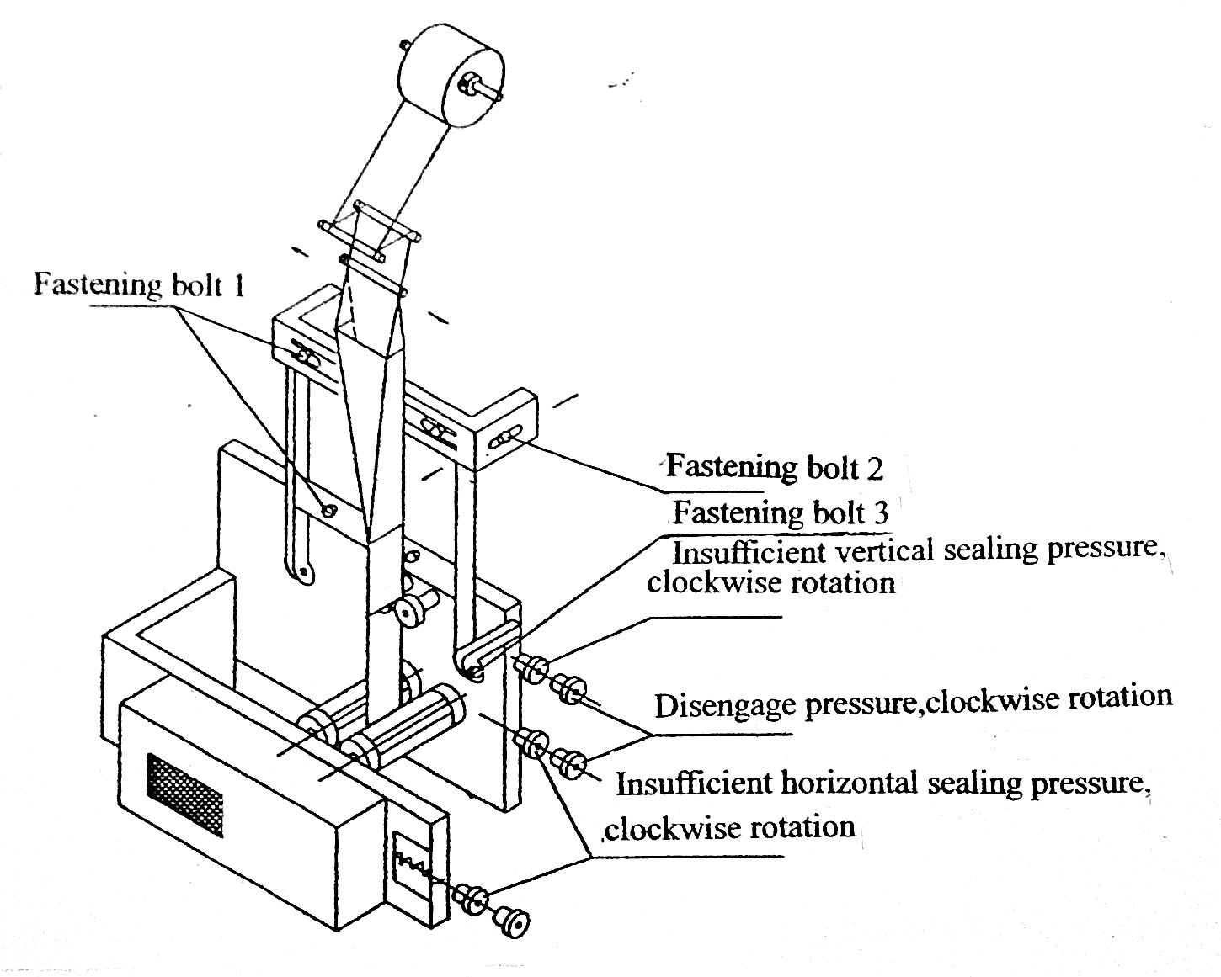

    - Make sure the shaper size is suitable for the paper width.
    - When the four edges of the packing bag take up lozenge shape, release the four fastening bolt 1, adjust in the right direction; and vise versa.
    - When the for edges of the packing bag take up lozenge shape release fastening bolt 2 for adjustment.
    - Adjustment to width of heat-sealed edge of vertical sealing, release fastening bolt 3, push it inwards for longer width, or vice versa.
    - For the adjustment of packing paper width, replacement of corresponding shaper is required.
※Adjustment for vertical sealing roller of inner bag (same for the equipment of tea bag and sachet)
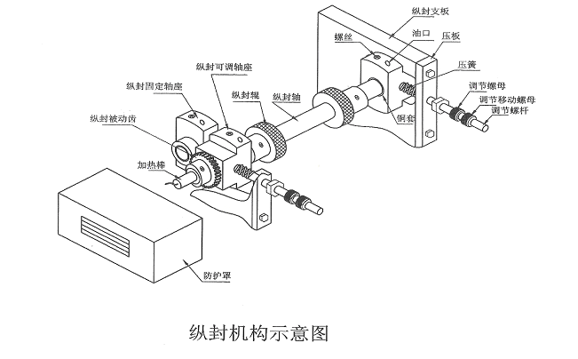

    - adjust the “pressure screw cap” to adjustment the press of the vertical sealing of the tea bag;
    - move the “sealing roller release screw cap” deasil to take the sealing roller release;
    - change the heating ring:
    - demount the “vertical sealing roller”;
    - demount the “ lock screw ring”;
    - demount the “ heating ring”;
    - setting a new “heating ring” on;
    - regress the “ lock screw ring” and “vertical sealing roller”.
    - change of the “cuprum bushing”
      - change the cuprum bushing on the adjustable axis:
      - demount the heating ring according a, b, c of step 3( change the heating ring) to demount the “vertical sealing roller”, “lock screw ring” and “heating ring” first;
      - demount the gear and the bracket;
      - demount the axis;
      - demount the “adjustable seat of axis”;
      - demount the cuprum bushing;
      - change new cuprum bushing on;
      - regress the “axis seat”, “bracket”, “gear”, “heating ring”, “lock screw ring”, “vertical sealing roller”.

      - Change the cuprum bushing on the unadjustable axis:
      - demount the heat ring on the unadjustable axis;
      - demount the gear on the immovable sealing axis;
      - demount 4 screw on the “unadjustable seat of the axis”;
      - demount the “seat of the axis”
      - demount the cuprum bushing in the seat;
      - change new cuprum bushing on;
      - regress the “seat”, “axis”, “gear”, “heating ring”.

    - Note: before changing the cuprum bushing, please bore the new cuprum bushing by reamer of ø20mm first. And when setting the new cuprum bushing on, imbruing the grease which heat-resistant over 200°C.
※Adjustment for horizontal sealing roller of outer bag
(Same as the equipments of tea bag and sachet)
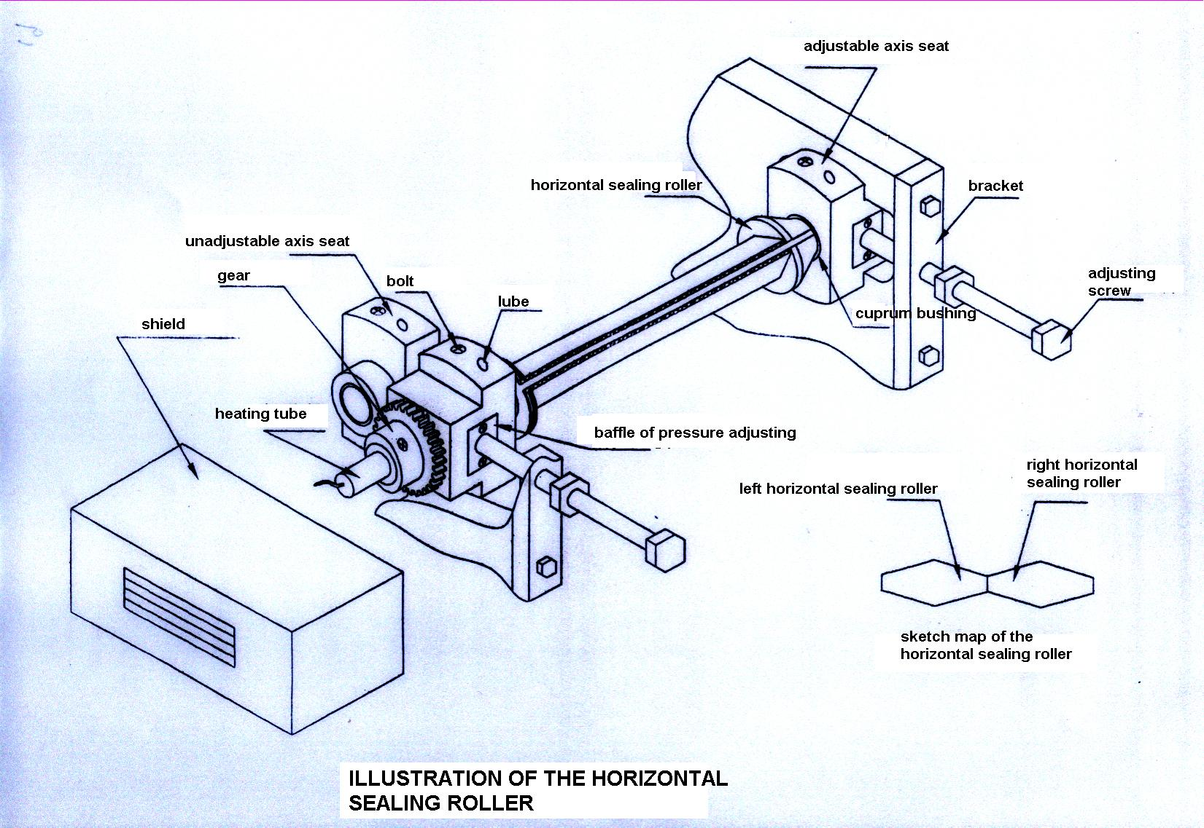

1.demount the shield and release the bolt on the gear and turn left horizontal sealing roller and right horizontal sealing roller to mesh both as the “sketch of the horizontal sealing roller” if the both sealing roller did not mesh well;
- turn the screw cap on the adjusting screw to adjust the pressure (derail to more and backspin less);
- change the cuprum bushing on the adjustable axis:
    - demount shield;
    - demount the stator of the heating tube;
    - demount the heating tube;
    - demount the gear (include the gear on the other end of the axis);
    - demount brackets and baffles of pressure adjusting and adjusting screws;
    - demount bushing seats on the ends of the axis;
    - release the bolt on the bushing seat and demount the cuprum bushing;
    - Change the new cuprum bushing on.

- changing the cuprum bushing on the uneducable axis:
Do as the adjustable axis as.

- Note: before changing the cuprum bushing, please bore the new cuprum bushing by reamer of ø25mm first. And when setting the new cuprum bushing on, imbruing the grease which heat-resistant over 200°C.

※Adjustment for vertical sealing roller of outer bag (same for the equipment of tea bag and sachet)
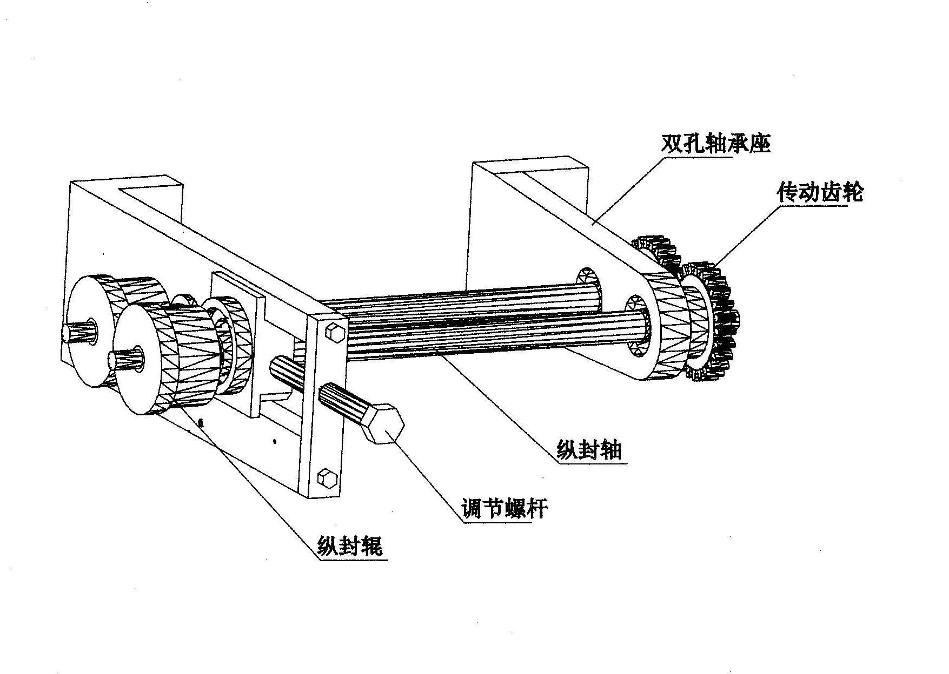

    - adjust the “pressure screw cap” to adjustment the press of the vertical sealing of the tea bag;
    - move the “sealing roller release screw cap” deasil to take the sealing roller release;
    - change the heating ring:
    - demount the “vertical sealing roller”;
    - demount the “ lock screw ring”;
    - demount the “ heating ring”;
    - setting a new “heating ring” on;
    - regress the “ lock screw ring” and “vertical sealing roller”.

    - change of the “cuprum bushing”
      - change the cuprum bushing on the adjustable axis:
      - demount the heating ring according a, b, c of step 3( change the heating ring) to demount the “vertical sealing roller”, “lock screw ring” and “heating ring” first;
      - demount the gear and the bracket;
      - demount the axis;
      - demount the “adjustable seat of axis”;
      - demount the cuprum bushing;
      - change new cuprum bushing on;
      - regress the “axis seat”, “bracket”, “gear”, “heating ring”, “lock screw ring”, “vertical sealing roller”.

      - Change the cuprum bushing on the unadjustable axis:
      - demount the heat ring on the unadjustable axis;
      - demount the gear on the immovable sealing axis;
      - demount 4 screw on the “unadjustable seat of the axis”;
      - demount the “seat of the axis”
      - demount the cuprum bushing in the seat;
      - change new cuprum bushing on;
      - regress the “seat”, “axis”, “gear”, “heating ring”.

    - Note: before changing the cuprum bushing, please bore the new cuprum bushing by reamer of ø20mm first. And when setting the new cuprum bushing on, imbruing the grease which heat-resistant over 200°C.
※Adjustment of open/close device
Loosen the bolts on open/close device frame and rotate filler plate.It is best when the device is fully open and the measuring-cup mouth is right opposite to the filler-feeding mouth.Fasten the bolt.

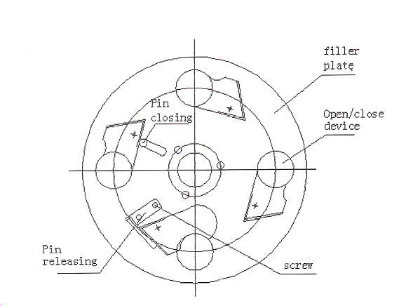

Sketch drawing of open/close device’s right position during filler feeding

※Adjusting the open peg and close peg
When adjusted the weight of the filling materials. The distance between leg and mobile turnplate had been changed. So must to adjust the leg to keep the distance in 2mm.
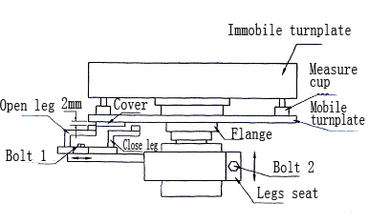

Adjust:
1.release the bolt 2 and move the legs seat to adjust the distance between leg and mobile turnplate in 2mm.
2.release the bolt 2 and turn the legs seat left right to take the measure cup at the filling trough above when the cover open full.
3.release the bolt 1. move open leg left right to take the cover open full. And move close leg left right to take the cover close complete.
Warning: the cover disallows to run into the flange when the cover open full.

※ Adjustment of the pneumatic bag catching manipulator
1. Operational principles:
Manipulator 9 controls Y- shaped clipping cylinder 8, making it move up and down which causes the connected clip head to close and open. Y- shaped clip 8 closes when manipulator 9 moves upwards, and it opens to loosen bags when manipulator 9 moves downwards. Thus, a process from inner bag packing to outer bag packing has been completed.
2. Adjustment of bag clipping time of Y- shaped clip 8:
The bag clipping time is primarily adjusted by the inductive signals of cams and inductive switches in Fig. 7. During adjustment, you should loosen the socket head cap screws on the cams first, then take the signal point on cams as the benchmarks, following which turn the cam clockwise to advance the clipping time or anti-clockwise to delay the clipping time (See cams in Fig. 7).
3. Adjustment of Y- shaped clip angle
Loosen screw 2 and adjust the swing degree of change gear plate 2 so as to adjust the working positions of the Y- shaped clip for traverse clipping bags. Loosen screw 1 and adjust the traverse position of change gear plate 1 so as to adjust the working positions of the Y- shaped clip for horizontal and vertical clipping bags.
Warning: The above angles have been strictly tested and corrected in the factory. Please DO NOT test or change them at your will.

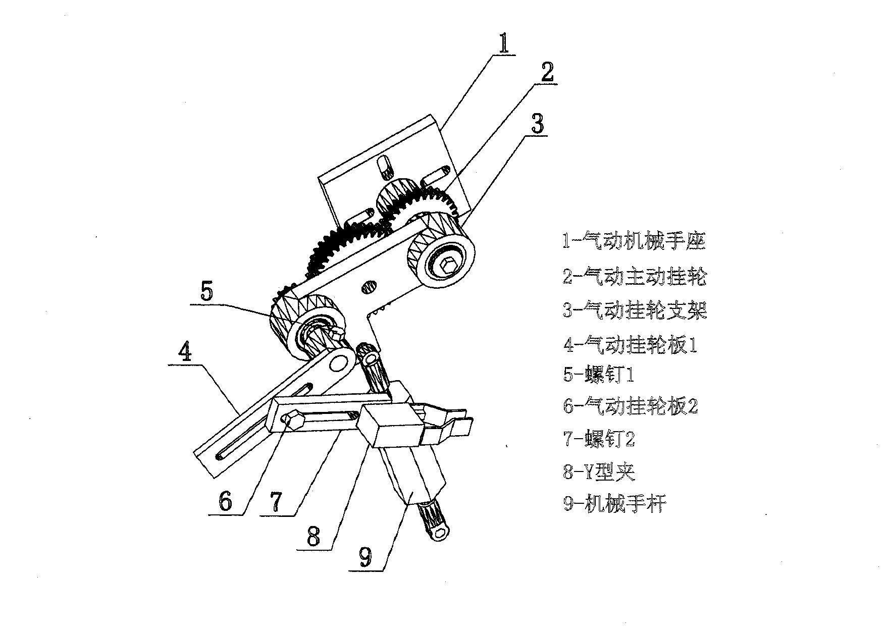

1- Pneumatic manipulator seat
2- Pneumatic driving change gear
3- Pneumatic change gear support
4- Pneumatic change gear plate 1
5-Screw 1
6- Pneumatic change gear plate 2
7- Screw 2
8-Y shaped clip
9- Manipulator

※ Adjustment of traverse seal eccentric mechanism
Function: to ensure that the line speed of traverse seal roller accords with
that of the vertical seal roller within the sealing time, so as to ensure the
quality.
Method of adjusting synchronization of vertical and traverse seal of inner
bags: loosen tension wheel 7 and detach clutch dial block 8 to place
eccentric chain wheel 5 and driving chain wheel 9 for traverse sealing of
inner bags in a free rotating state, adjust eccentric disc 6 to keep the
center of eccentric shoe 4 and the center of eccentric seat 1 at a level
position, and to make the traverse seal roller at a level position at the
same time to ensure the synchronization of vertical and traverse seal of
inner bags (Fig. 9)
Adjustment of Traverse Seal Mechanism of Inner and Outer Bags)
Adjustment of traverse seal length of inner bags: turn adjusting hand
wheel 2, clockwise to enlarge the eccentric distance so as to make the
outer bag length longer; turn adjusting hand wheel 2 anti-clockwise to
reduce the eccentric distance so as to make the outer bag length shorter.
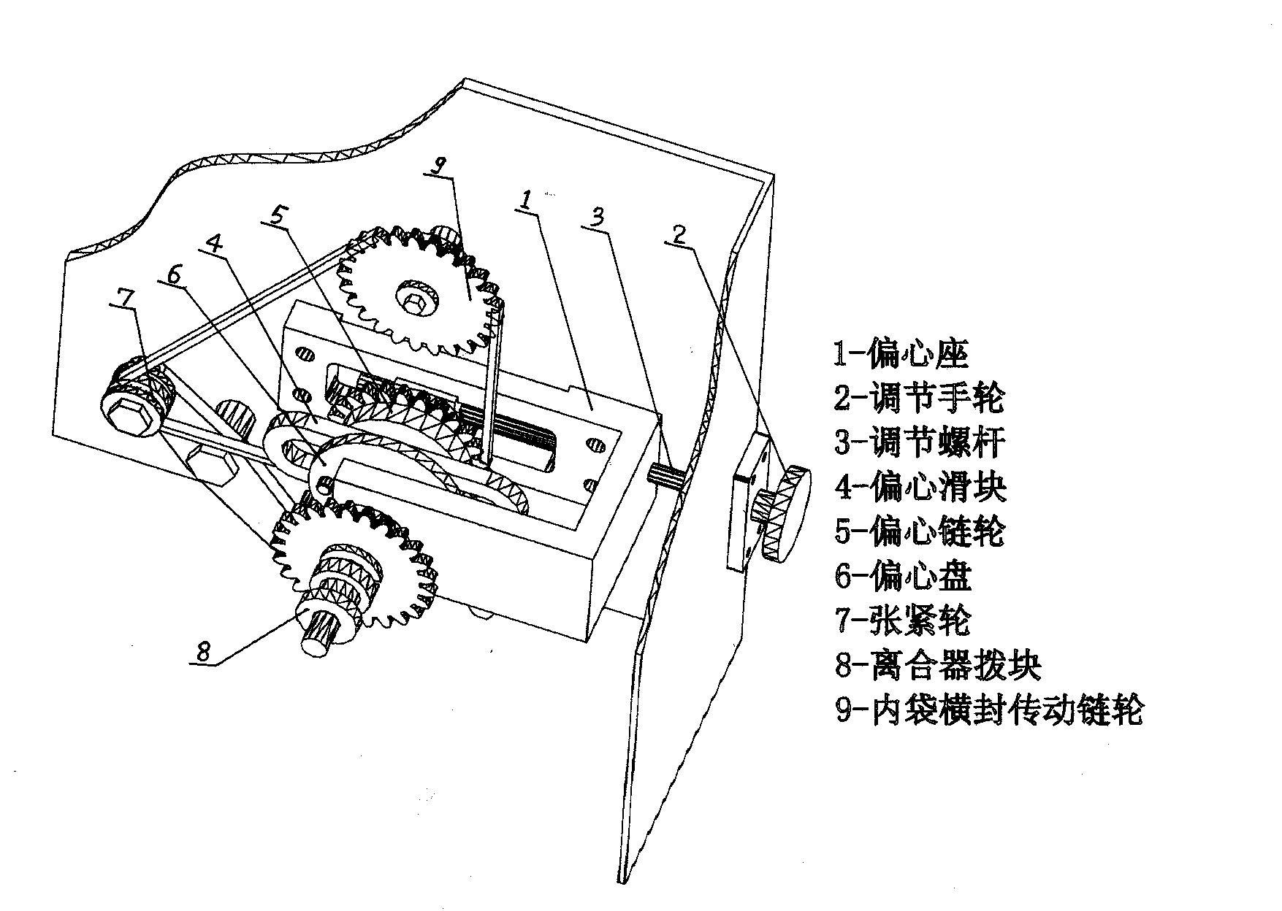

Fig. 13

1- Eccentricity 2- Adjusting hand wheel
3- Adjusting bolt 4- Eccentric shoe
5- Eccentric chain wheel 6- Eccentric disc
7- Tension wheel 8- Clutch dial block
9- Driving chain wheel of traverse seal of inner bags

VI.Electric Wiring Diagram
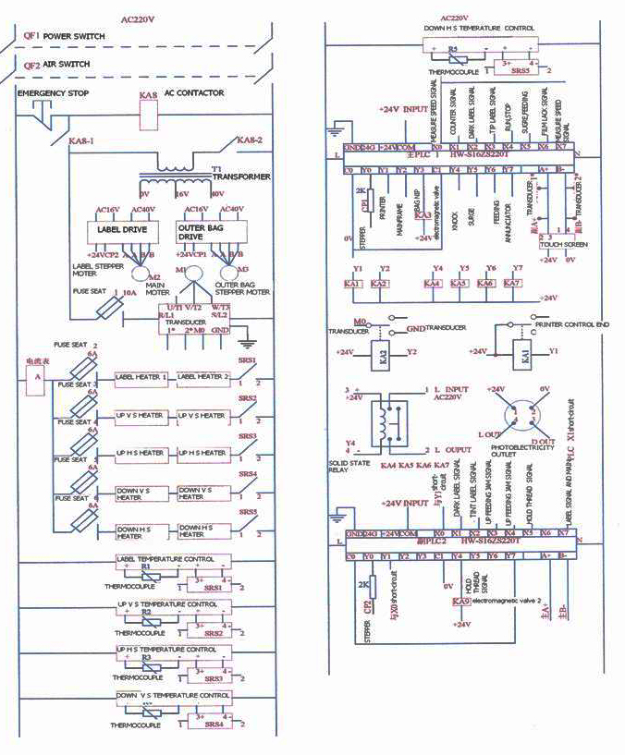

VII. Trouble-shooting
Trouble | Cause | Solution to trouble
Some mechanisms do not work | Open circuit of motor | Replace motor or connect circuit
Abnormal machine running | Foreign objects in gears or moving parts | Shut off machine for repair
Burnt sealing | No oil lubrication at thermal sealing roller bearings | Bearing key is detached inject oil and fasten tight.
Bad sealing of packing bags | Uneven left and right pressure on thermal sealing roller | Adjust pressure
Bad sealing of packing bags | Thermal sealing roller wear-off | Replace thermal sealing roller
Bad sealing of packing bags | Unclean where thermal sealing is applied | Clean with copper brush
Bad sealing of packing bags | Packing paper has bad quality | Contact with packing paper manufacturer
Bad sealing of packing bags | Copper sheath wear-off | Replace copper sheath
Sealing disabled | Heating components burnt out | Replace heating components
Sealing disabled | Bad electric components | Check and replace
Corrugation and packing film sealing not aligned | The centerline of packing film does not match with thermal roller dimension | See adjust The Shaper of The Filter Bag(inner bag)
Corrugation and packing film sealing not aligned | Forming instrument bad adjustment | See adjust The Shaper of The Filter Bag(inner bag)
Sealing contains or leaks filler | Different filler feeding time (Due to air resistance)
Sealing contains or leaks filler | Filler feeding time does not fit in with thermal sealing time
Bad cut | Cutter gear wear-off | Replace cutter
Bad cut | Blunt or damaged cutter edge | Replace or sharpen cutter

